Student Name: Abayawardena W.A.A.U.
Student ID: IT24102701
GitHub Repository Link: https://github.com/IT24102701/WMT_Lab_Test_Project
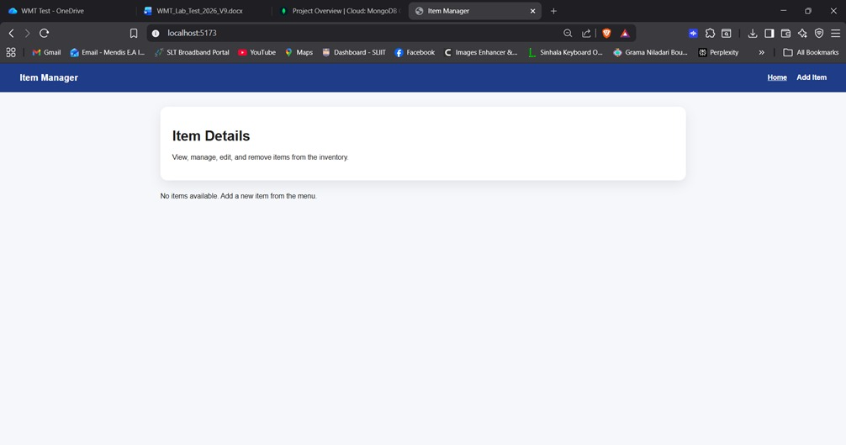
Existing Home Page

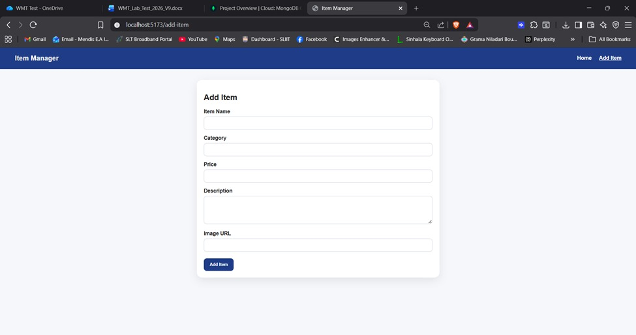
Existing Add Item Page
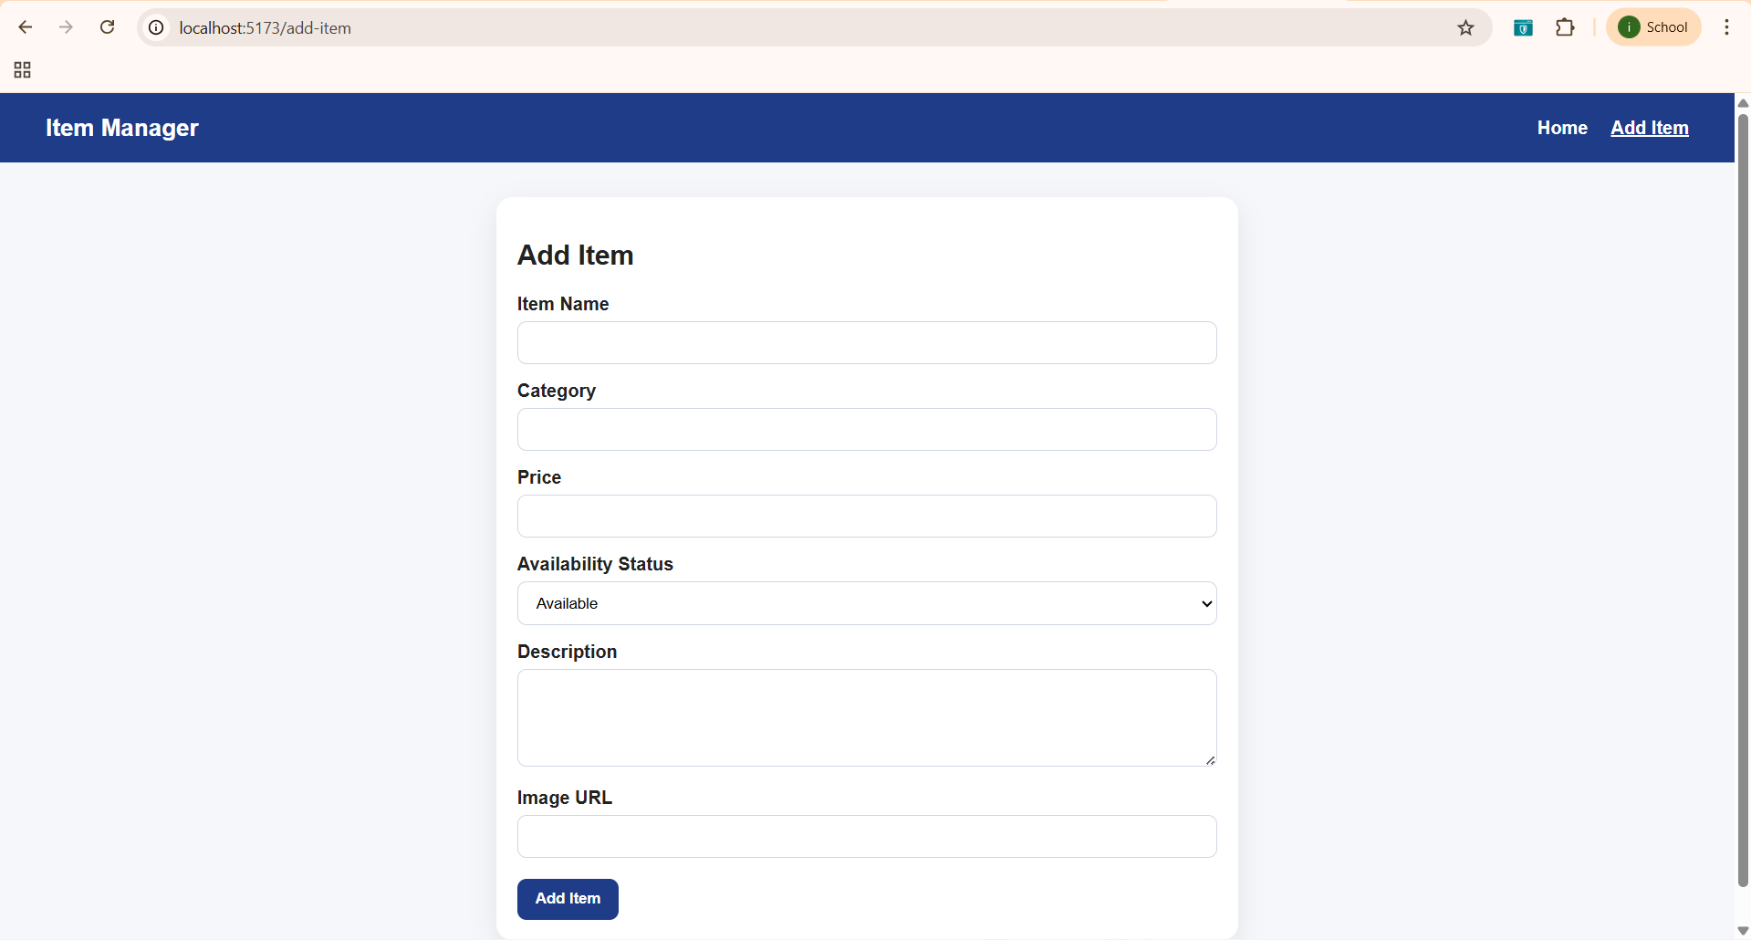
Updated Add Item Page

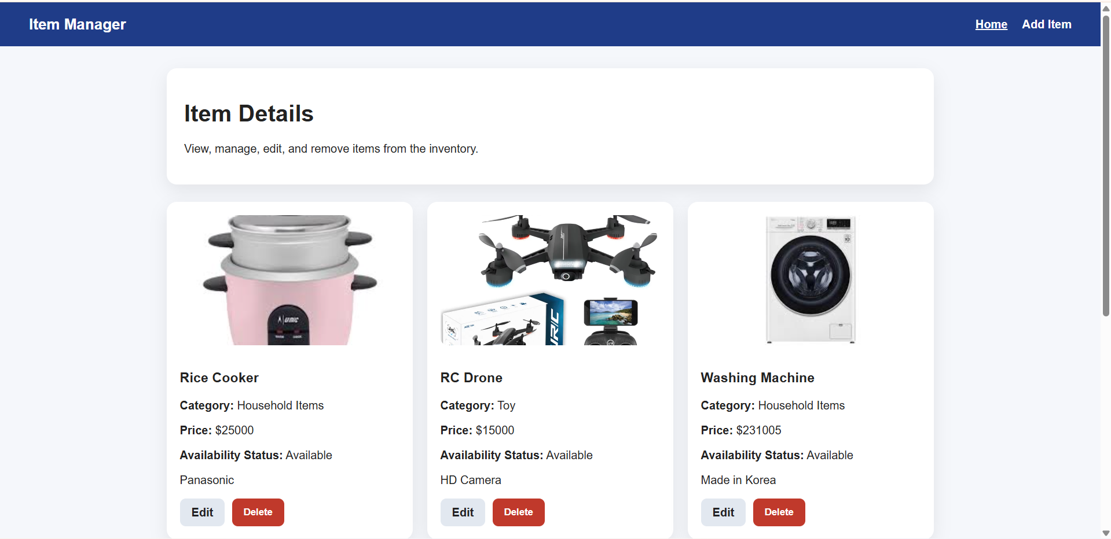
Updated Home Page

